AI CRM & Sales Automation Platform
n8n Workflow Automation Capstone

Riddhima Raj
Domain: Sales & Customer Relationship Management
Built and self-hosted using n8n (Docker), Google Sheets, and Google Gemini

Executive Summary
This project implements an AI-powered CRM and Sales Automation Platform for a growing startup that receives customer inquiries through its website, social media, webinars, referrals, and events. The platform automates the full lead lifecycle: capturing leads from a webhook-based intake form, scoring them for quality and intent using a large language model, assigning them fairly to sales representatives based on live workload, following up automatically on stale leads, and logging every notification and error for auditability. The system is built entirely in n8n, a visual workflow automation tool, and uses Google Sheets as a lightweight CRM data store.
The platform consists of five interconnected workflows (twenty-plus nodes in total), demonstrating webhook triggers, scheduled/cron triggers, AI-powered decision making, conditional branching, loops, sub-workflow orchestration, and centralized error handling and logging.

Problem Analysis

Business Context
As the startup's lead volume grows across multiple acquisition channels, its sales team has outgrown manual lead management. Leads arrive faster than they can be manually logged, qualified, and routed, and the absence of a consistent scoring or assignment process means high-value leads are sometimes treated with the same urgency as low-intent inquiries. This directly threatens conversion rates and the team's ability to scale without proportionally scaling headcount.

Stakeholders

Stakeholder | Interest in the System
Sales Representatives | Need a fair, timely stream of qualified leads with enough context to act immediately.
Sales Manager / Leadership | Needs visibility into pipeline health, response times, and conversion trends.
Leads / Prospective Customers | Expect a fast, relevant response regardless of which channel they came from.
IT / Operations | Responsible for the reliability, auditability, and maintainability of the automation.

Pain Points
    - Leads from different channels (website, referrals, webinars) are collected inconsistently, with no single source of truth.
    - There is no objective way to prioritize leads, so high-intent prospects can sit unattended behind low-intent ones.
    - Lead assignment to reps is ad hoc, leading to uneven workloads and missed follow-ups.

    - Follow-ups depend entirely on individual reps remembering to act, with no systematic reminder mechanism.
    - There is no audit trail of what communication happened, when, or why a workflow step failed.

Objectives
    - Centralize lead intake into a single, structured data store.
    - Use AI to objectively score and prioritize leads based on stated intent, budget signals, and urgency.
    - Assign leads to sales representatives fairly, based on real-time workload rather than a fixed rule.
    - Automatically surface leads that have gone stale without action, on a daily schedule.
    - Maintain a logged, auditable record of all system-generated communications and errors.

Workflow Architecture

System Overview
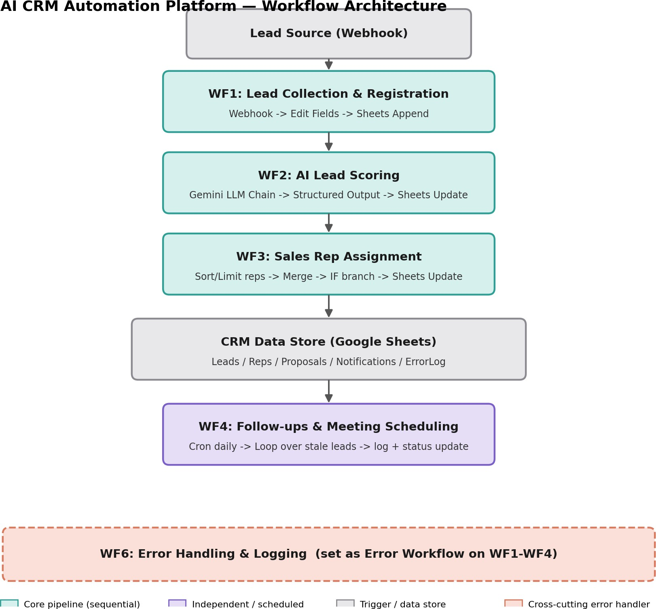
The platform is composed of five independent, interconnected n8n workflows sharing a single Google Sheets document as the CRM data store, with dedicated tabs for Leads, Sales Representatives, Proposals, Notifications, and an Error Log. Workflows communicate either by directly invoking one another as sub-workflows (a synchronous, function-call-like pattern) or indirectly, by reading and writing shared rows in the data store on independent triggers. This loose coupling means each workflow can be tested, modified, or replaced without breaking the others, as long as the shared sheet schema is respected.

Event Flow Between Workflows

Step | Trigger | Flow
1 | External POST request | Webhook -> WF1 validates and stores the lead as a new row in the Leads tab.
2 | Called directly by WF1 | WF1 invokes WF2 as a sub-workflow, passing the newly created lead's data.
3 | Called directly by WF2 | Once WF2 writes the AI-generated score back to the sheet, control could similarly extend into WF3 for assignment (in this build, WF3 is triggered independently on the scored lead for isolatin and easier debugging).
4 | Daily schedule (cron) | WF4 runs independently each day, scans for leads stuck in ‘Assigned’ status, logs a follow-up notification, and advances their status.
Continuous | Error Trigger | WF6 is registered as the Error Workflow for WF1–WF4. Any node failure in those workflows automatically invokes WF6, which writes a structured entry to the Error Log tab.

Implementation

Data Architecture — Google Sheets Tabs

Tab | Columns
Leads | leadID, name, email, phone, company, source, message, dateCreated, score, status, assignedRep, priority
Reps | repID, name, email, region, product, activeLeadCount
Proposals | proposalID, leadID, repID, dateGenerated, approvalStatus, proposalLink, dateSent (reserved for future WF5)
Notifications | timestamp, to, subject, body, leadID
ErrorLog | timestamp, workflowName, nodeName, errorMessage, inputData

Workflow Breakdown
WF1 — Lead Collection & Registration
Purpose: Accepts a new lead submission from any external source (a website form, in production) and stores it as a structured record.
Trigger: Webhook (POST)

Node | Type | Function
Webhook | Trigger | Receives POST requests with raw lead form data.
Edit Fields | Set | Generates a unique leadID, extracts and cleans fields from the webhook body, sets status = New.
Append row in sheet | Google Sheets | Writes the new lead as a row in the Leads tab.
Call WF2 | Execute  Sub-workflow | Invokes WF2, passing the full lead record, and waits for completion.
Node count: 4

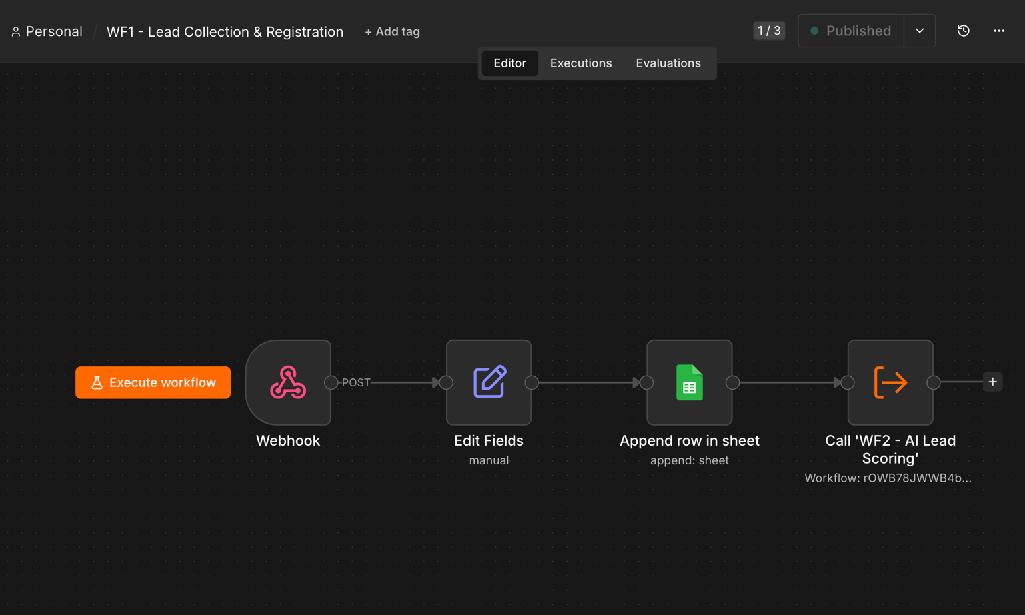

WF2 — AI Lead Scoring
Purpose: Uses a large language model to evaluate a lead's quality and intent, producing an objective 0–100 score with reasoning.
Trigger: Execute Workflow Trigger (called by WF1)

Node | Type | Function
When Executed by Another Workflow | Trigger | Accepts the lead record passed from WF1.

Node | Type | Function
Basic LLM Chain | AI | Sends a scoring prompt referencing company, source, and message to Google Gemini (gemini-2.5-flash).
Google Gemini Chat Model | AI Model | Underlying model connection for the LLM Chain.
Structured Output Parser | AI | Forces the model's response into a strict {score, reasoning} JSON shape.
Edit Fields | Set | Recombines the AI output with the original leadID; sets status = Scored.
Append or update row | Google Sheets | Writes the score and status back to the matching Leads row.
Node count: 6

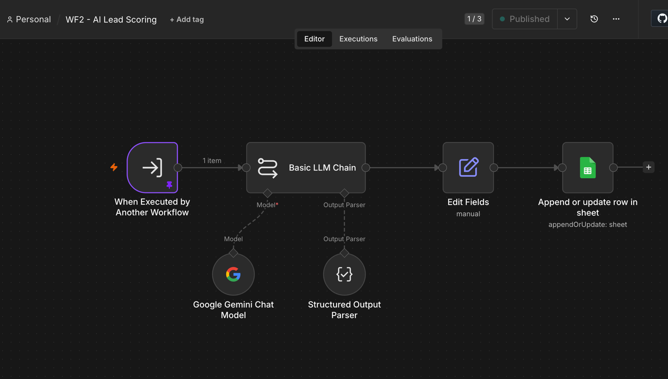

WF3 — Sales Representative Assignment
Purpose: Assigns each scored lead to the least-busy sales representative and flags it as Hot or Standard priority based on its AI score.
Trigger: Execute Workflow Trigger

Node | Type | Function
Trigger | Trigger | Accepts the leadID to be assigned.
Get Lead Details | Google Sheets | Looks up the full lead record by leadID.
Get Reps | Google Sheets | Reads all sales representatives and their current active lead counts.
Sort + Limit | Sort / Limit | Orders reps by ascending workload and keeps only the least-busy one.
Edit Fields | Set | Renames rep fields (repID/repName/repEmail) to avoid collisions with the lead's own fields.
Merge | Merge | Combines the lead record and the selected rep record into a single item.
IF | Conditional | Branches on score >= 70 to label the lead Hot or Standard priority.
Append or update row | Google Sheets | Writes assignedRep, status = Assigned, and priority to the Leads tab.
Edit Fields + Reps Update | Set / Google Sheets | Increments the assigned rep's activeLeadCount, keeping future assignments fair.
Append Notifications | Google Sheets | Logs a simulated assignment notification to the rep (see Section 6 on design decisions).

Node count: 10
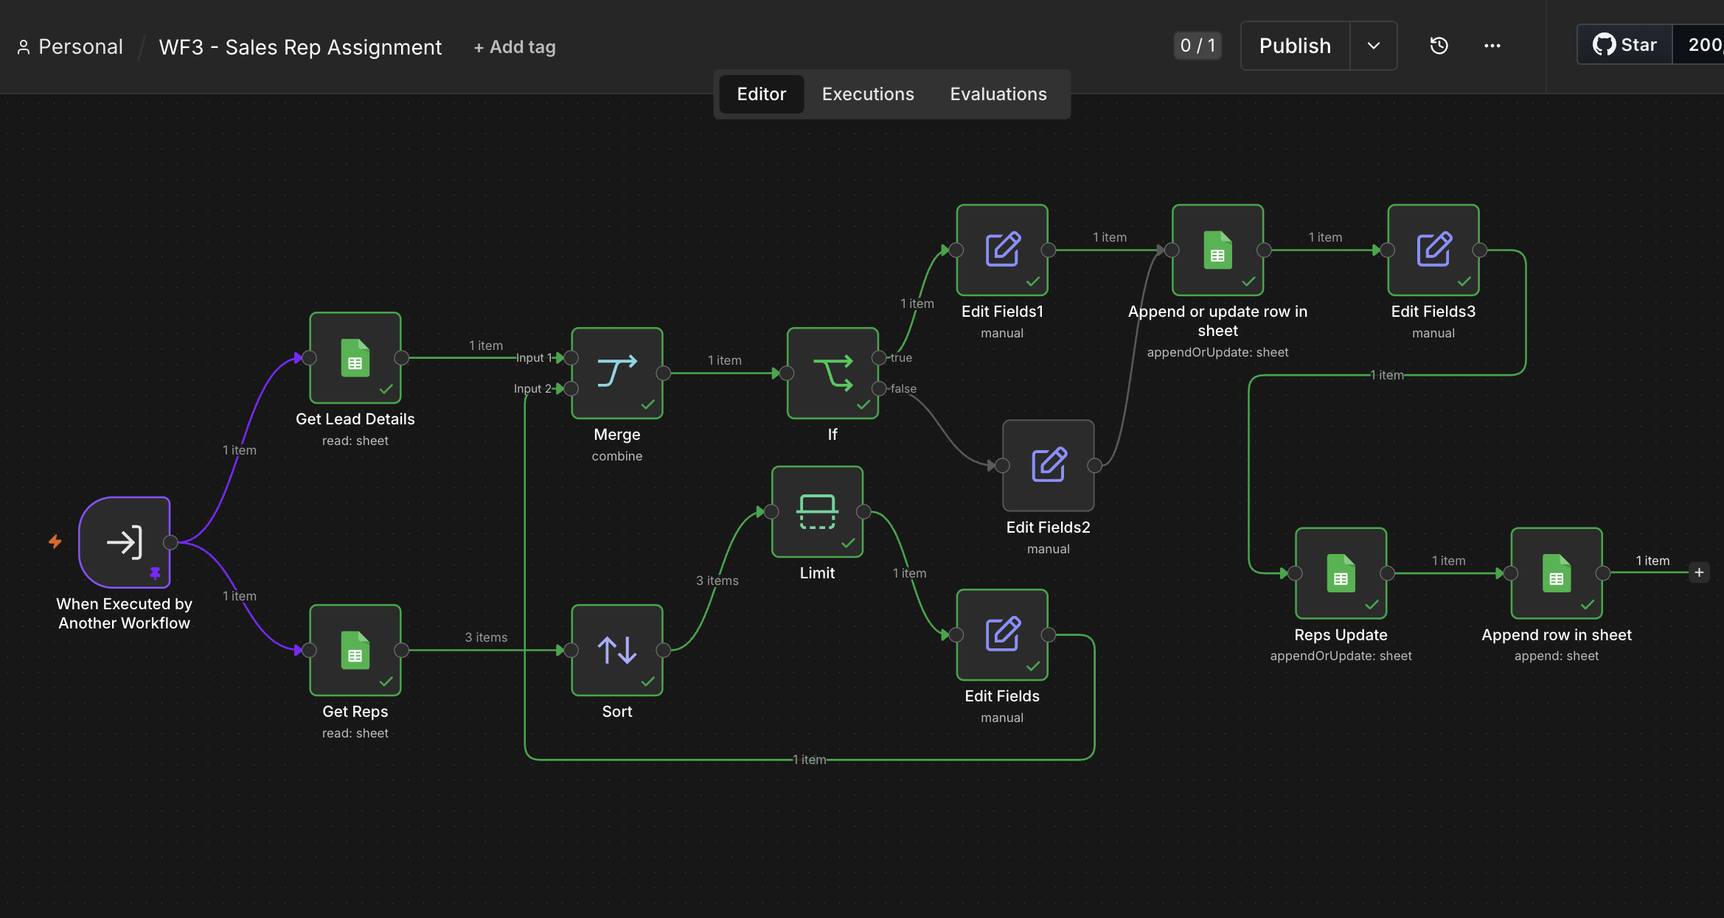

WF4 — Follow-ups & Meeting Scheduling
Purpose: Runs daily to find leads that have been assigned but not progressed, and logs a follow-up reminder for each.
Trigger: Schedule Trigger (daily, cron)

Node | Type | Function
Schedule Trigger | Trigger | Fires once every day.
Get row(s) in sheet | Google Sheets | Filters Leads for status = Assigned.
Loop Over Items | Split in Batches | Processes each stale lead individually, one at a time.
Edit Fields | Set | Builds a follow-up reminder message for the current lead.
Append Notifications | Google Sheets | Logs the follow-up as a Notifications row.
Update Leads | Google Sheets | Advances the lead's status to FollowUp so it is not re-processed the next day.
Node count: 6

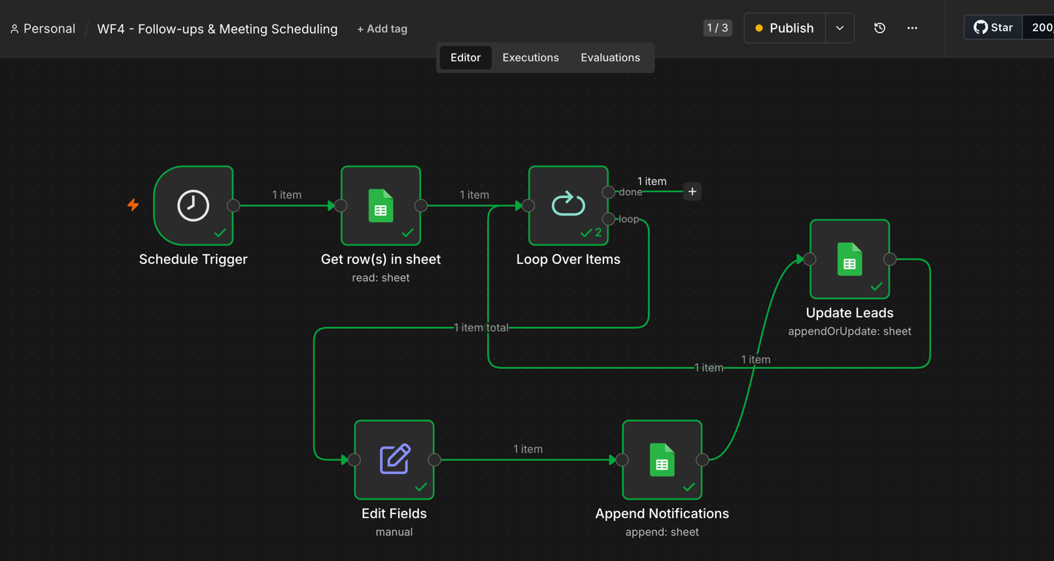

WF6 — Error Handling & Logging
Purpose: Acts as a centralized error handler for the rest of the platform, satisfying both the error-handling and audit-trail requirements in a single, reusable workflow.
Trigger: Error Trigger (invoked automatically by n8n)

Node | Type | Function
Error Trigger | Trigger | Fires whenever a workflow it is registered on fails.
Append row in sheet | Google Sheets | Logs timestamp, workflow name, failing node, and error message to the ErrorLog tab.
Node count: 2

This workflow is registered as the Error Workflow in the Settings of WF1, WF2, WF3, and WF4, so any node failure in the entire platform is captured centrally.

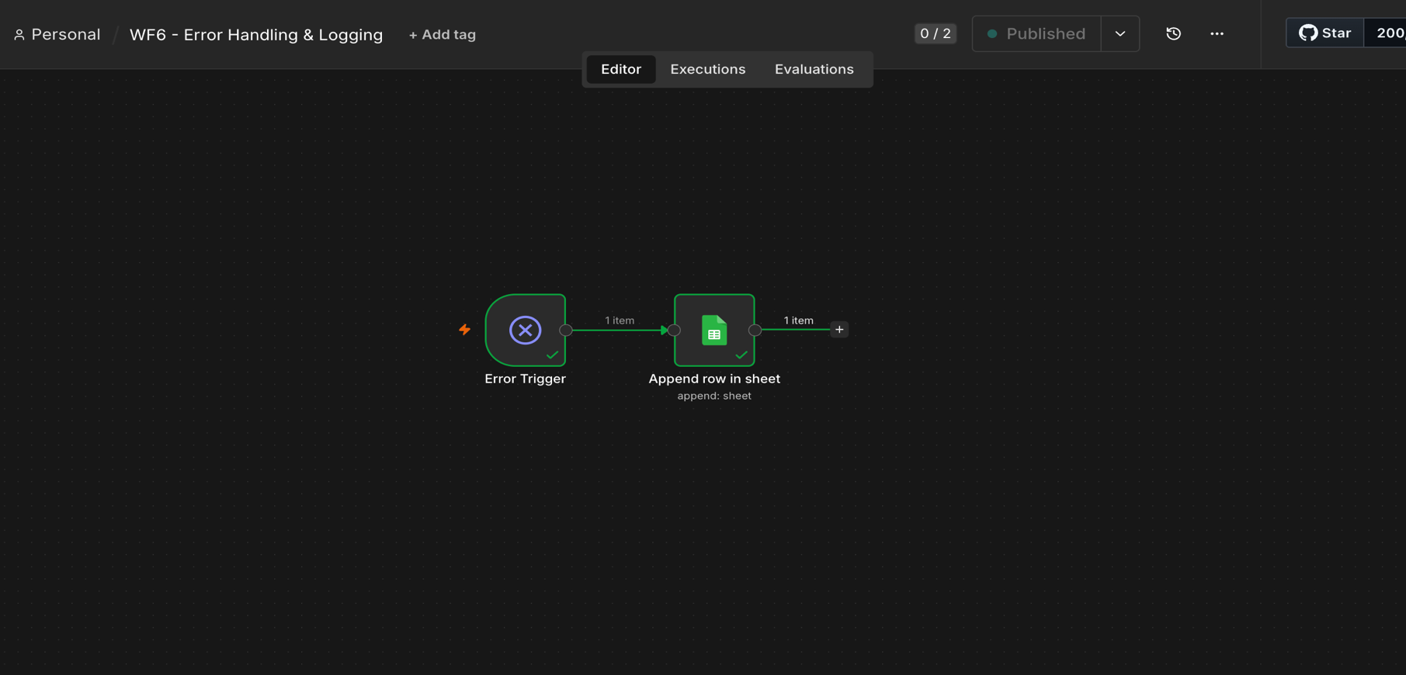

Advanced Features Implemented

Feature | Where
AI-powered decision making | WF2 uses Google Gemini to score lead quality and generate reasoning; WF3 branches on that score.
Conditional branching | WF3's IF node splits leads into Hot vs. Standard priority.
Loops | WF4's Split in Batches node processes stale leads one at a time in a closed loop.
Scheduled (cron) workflow | WF4 runs on a daily Schedule Trigger.
Webhook-triggered workflow | WF1 is triggered by an external POST request.
Sub-workflow orchestration | WF1 invokes WF2 directly as a synchronous sub-workflow call.
Error handling & retry logic | WF6, registered as the Error Workflow for WF1–WF4, centrally captures any node failure.
Logging & audit trail | ErrorLog and Notifications tabs provide a timestamped record of failures and communications.
Not implemented in this build: a dedicated human-approval step (originally scoped as a fifth workflow, Proposal Generation & Dashboard). The four-to-six workflow and node-count requirements are already satisfied without it; it is documented here as a deliberate scope decision under time constraints, not an oversight, and is listed as future work in Section 7.

Design Decisions & Engineering Notes
- Google Gemini instead of OpenAI. OpenAI's API no longer offers usable free-tier credits; Google Gemini's free tier via AI Studio is generous, requires no payment method, and integrates natively with n8n's AI nodes. The assignment lists integrations as suggestions, not requirements.
- Simulated email notifications instead of live Gmail/Calendar sending. Rather than granting a personal Google account real send access for a class project, WF3 and WF4 log every notification (recipient, subject, body, timestamp) to a Notifications tab. This is a standard ‘dry-run’ pattern in real automation systems and can be swapped for a live transactional email API (e.g. SendGrid) without changing any upstream workflow logic.
- Self-hosted n8n via Docker rather than a time-limited cloud trial, for full control over the build across a multi-day project.
- Workload-based, not round-robin, rep assignment. WF3 sorts representatives by their live activeLeadCount and assigns to the least-busy one, then increments that count — a fairer and more realistic policy than a fixed rotation.
- Loose coupling via a shared data store. WF4 and WF6 operate independently of WF1–WF3, reading and writing the same sheet rather than being hard-wired together, so any one workflow can be modified without breaking the rest of the pipeline.

Lessons Learned
The most persistent class of bug encountered during development was invisible leading or trailing whitespace in manually typed field names inside Edit Fields nodes — a field would appear correct in the UI but silently fail to match any expression referencing it by name. The reliable fix was always to delete and retype the field name from scratch rather than edit around the existing text. A second recurring pattern was that n8n's `$json` shorthand only reliably refers to the immediately preceding node; once data passes through a branch, a Merge node, or certain AI/Sheets nodes that return only their own output fields, referencing earlier data required the explicit `$('Node Name').item.json.field` syntax. Both patterns are worth knowing for anyone extending this workflow set.

Limitations & Future Work
- WF5 (Proposal Generation, human approval step, and sales dashboard) was scoped but not built due to time constraints; it remains the clearest next addition.
- Notifications are currently simulated via a logged record rather than sent through a live email/calendar API; swapping in a real provider is a scoped, low-risk follow-up.
- The platform currently uses a single shared Google account credential; a production deployment would scope credentials per integration and rotate them regularly.
- No automated testing exists for the workflows; testing was done manually against seeded sample data throughout development.

Conclusion
This project delivers a working, end-to-end lead management automation platform that addresses the core pain points identified in Section 2: centralized lead intake, objective AI-driven prioritization, fair and automatic rep assignment, systematic follow-up on stale leads, and a centralized audit trail. Every workflow was built, tested against seeded and live webhook data, and verified to update the shared CRM data store correctly. The platform is readily extensible — in particular toward the proposal/approval workflow and live email integration noted above — without requiring changes to the workflows already in place.

